Machine Learning-Based Fetal Health Prediction Using Cardiotocography Data with an Interactive Decision Support System

Contents
Machine Learning-Based Fetal Health Prediction Using Cardiotocography Data with an Interactive Decision Support System 1
Introduction 3
Dataset Description & Understanding 3
Data Quality & Preprocessing 4
Exploratory Data Analysis 6
Model Development 7
Model Evaluation & Results 8
Hyperparameter Tuning & Improvement 10
Model Explainability 10
System Implementation (Streamlit Application) 12
Limitations 13
Conclusion 13
References 14

Introduction
Fetal health is perhaps one of the most important factors during pregnancy. Thanks to the advancements in medical technology, model Machine Learning Models are being constantly implemented to assess the fetus’s well-being and identify risks like hypoxia (oxygen deprivation) during pregnancy and labor (Wong et al., 2025).
Our ML and data analysis models are trained on Cardiotocography (CTG) data. These models analyze fetal heart rate (FHR) and uterine contractions and ultimately classify health as normal, suspect, or pathological (Wong et al., 2025). The aim of such models is to reduce infant mortality and improve clinical decision-making.
Machine Learning is exceptionally efficient at analyzing complex, high-dimensional data (e.g., CTG data) to detect subtle changes and anomalies (Zhang et al., 2023). And for fetal health, such finely tuned detection can be instrumental in identifying early signs of fetal distress, which are difficult for human clinicians to interpret (Zhang et al., 2023).
The system created in the project does multi-classification of fetal health conditions using cardiotocography (CTG) data. It is used to predict a case as either Normal, Suspect or Pathological based on the input features. Moreover, an interactive Streamlit application was introduced to enable users to provide measurements of CTG and get real-time predictions and probability scores.

Dataset Description & Understanding
The data to be analyzed in this research includes cardiotocography (CTG) fetal health measurements. It has 2126 observations comprising 21 input features and a single target variable as indicated in Figure 1.
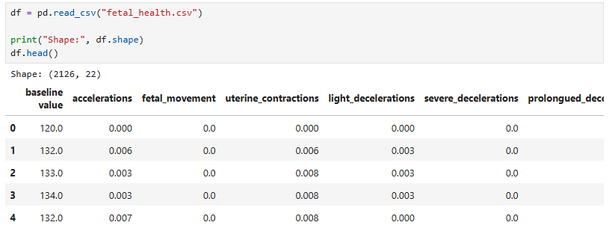
Figure 1: Figure 1_Dataset Overview.
Based on Figure 2, variables are all numerical and are stored as floating-points. This is beneficial to modeling because it can directly implement machine learning algorithms, without having to encode. The features are physiological features which include baseline heart rate, accelerations and variability patterns.
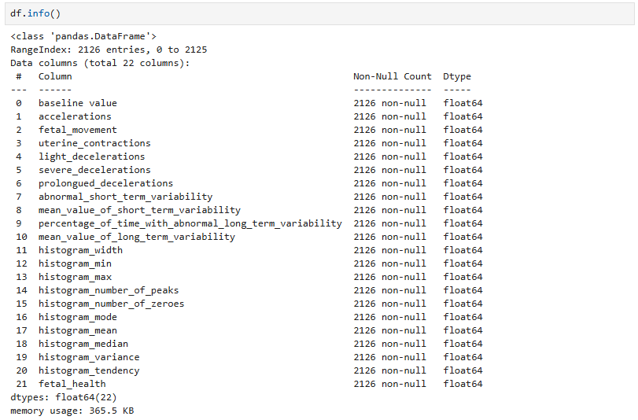
Figure 2: Dataset Structure and Data Types.
Fetal health, a target variable, is three-class variable, where the variables include Normal (1), Suspect (2), and Pathological (3): such variable represents a multi-class classification problem. As the data have been obtained through actual physiological signals, they offer a significant foundation of learning patterns, which are related to the condition of fetuses, yet they should still be interpreted in the light of the clinical situation.

Data Quality & Preprocessing
Quality of the dataset was initially evaluated. Figure 3 indicates that there are no missing values, making preprocessing easier. Nonetheless, they were able to define duplicate records and eliminate them to prevent the bias in training.
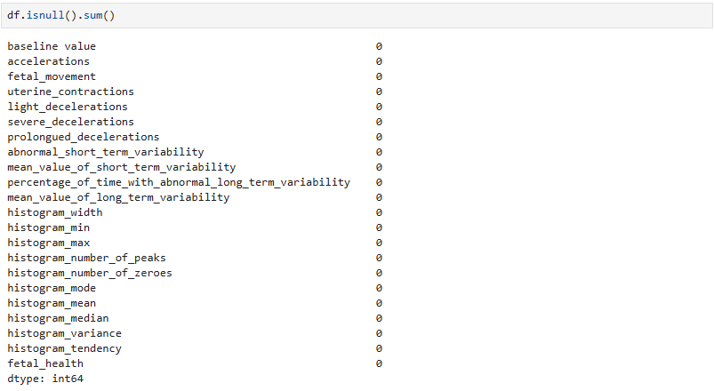
Figure 3: Missing Values Check.
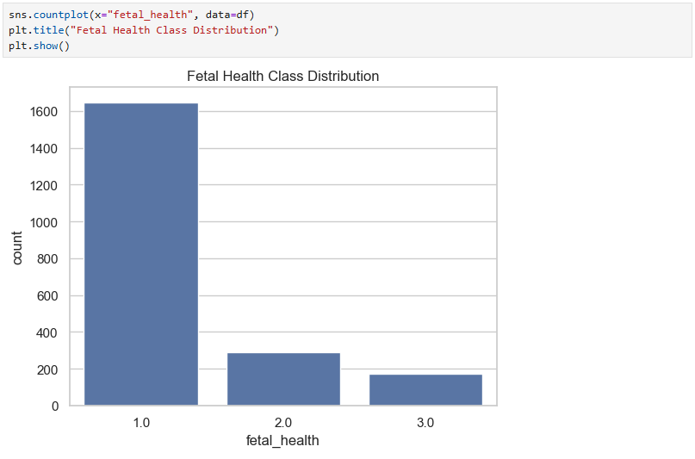
Figure 4: Target Variable Distribution
The data was divided into training and test dataset at 80:20 ratio as shown in Figure 5, and stratification was used to maintain the balance in class. This is significant due to the inequality in the dataset where its representation will be balanced in both of the subsets.

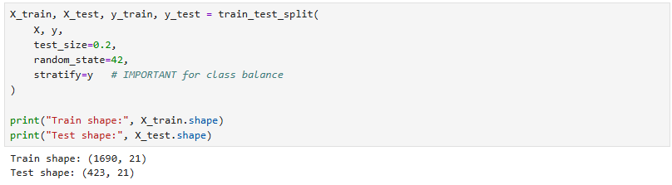
Figure 5: Train-Test Split.

To achieve feature scaling, standardization was done and the means of the features are near zero with standard deviations near that of one as indicated in Figure 6. The step helps make the model more stable and will ensure that no individual feature is going to be dominant with scale differences.
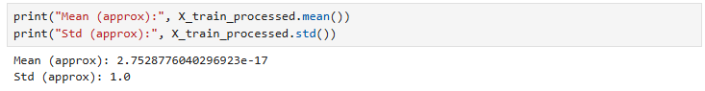
Figure 6: Feature Scaling Verification
In general, preprocessing concentrated on data integrity maintenance and drawing up of a dataset suitable to be trained in a reliable model.

Exploratory Data Analysis
To get insights on the distribution of the, an exploratory analysis was done. target variable. Figure 4 indicates that the data is skewed, with majority of. There are examples of the Normal class.
And this imbalance has significant meanings. A model optimized on the basis of. accuracy can be very good at predicting a dom dom depending class, but fail to recognize. minority cases. On this basis, these evaluation metrics like macro F1-score were. preferred, because they present a representation of the performance more balanced (Cömert and). Kocamaz, 2017). This imbalance is also indicative of real world clinical situations where abnormal is at play. conditions are less common (Grivell et al., 2015), which supports the necessity of. careful evaluation.

Model Development
Fetal health was categorized using three models of Logistic Regression, Decision Tree and Random Forest.
- Logistic Regression was used as a baseline linear model
- Decision Tree captured non-linear relationships but risked overfitting
- Random Forest combined multiple trees to improve stability and accuracy (Al Duhayyim et al., 2023)
All the models were constructed with pipelines in order to guarantee uniform preprocessing and prevent data leakage. Stratified cross-validation was used to assess performance and give a good estimate across various data splits (Regmi and Shah, 2023).
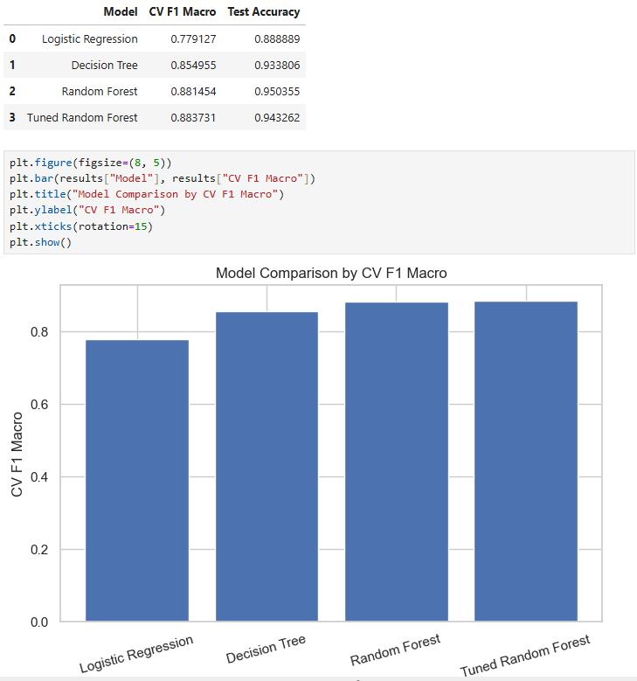
Figure 7: Model Comparison (F1 Score).
Random Forest performed better than the other models as displayed in Figure 7, thus revealing that ensemble methods are more superior in determining the intricacies of CTG data.

Model Evaluation & Results
The final model chosen after training and comparing various models was the tuned Random Forest because of its strong and consistent performance with regard to evaluation metrics.
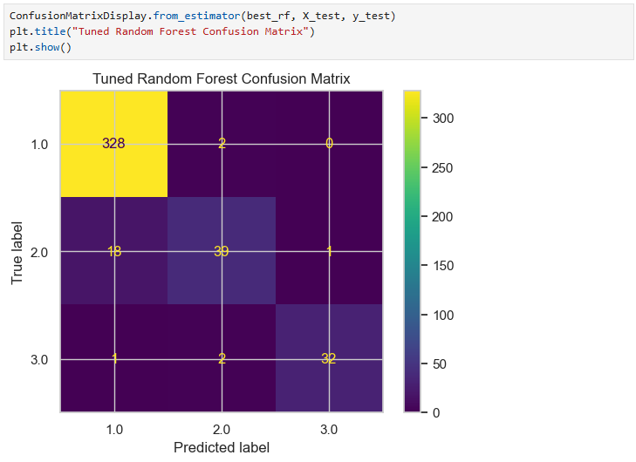
Figure 8: Confusion Matrix of Final Model.
The confusion matrix of the last model is shown in Figure 8, which gives a detailed picture of the classification results in all three classes.
Key observations from the confusion matrix:
- The model performs exceptionally well in identifying the Normal class, with most instances correctly classified.
- The Pathological class is also predicted with high accuracy, which is particularly important from a clinical perspective, as these cases indicate potential risk.
- The Suspect class exhibits rather poor performance, and some false classification of the Suspects into the Normal category.
This pattern is not unexpected. The Suspect class represents borderline conditions that often share characteristics with both Normal and Pathological cases. As a result, the boundaries between these classes are less distinct, making classification more challenging (Nazli et al., 2025).
Performance summary:
From the evaluation results:
- High overall accuracy indicates strong general performance
- Macro F1-score confirms balanced performance across classes
- Precision and recall remain high for most categories
Nevertheless, basing it purely on the accuracy would be deceptive because of the imbalance in classes. By using macro F1-score, emphasis to the minority classes during evaluation is equal (Cömert and Kocamaz, 2017).
Model comparison insight (Figure 7):
- Logistic Regression underperforms, suggesting that the relationships in the dataset are not strictly linear
- Decision Tree improves performance but shows signs of overfitting
- Random Forest provides the best balance between bias and variance
This development has shown that more relaxed models need to be used to reflect the complexity of physiological information.
Critical evaluation:
The model’s strengths lie in its ability to:
- Capture non-linear relationships between features
- Handle interactions between multiple variables
- Maintain strong performance across different validation folds
Simultaneously, the fact that the Suspect class fell slightly in performance indicates a weakness:
- The presence of overlapping feature distributions makes some of the cases ambiguous in nature.
- Even highly developed models are unable to separate these borderline conditions completely.

Hyperparameter Tuning & Improvement
Hyperparameter tuning was further used to the Random Forest classifier with the help of RandomizedSearchCV to further improve model performance. The method enables effective search of a large set of parameter combinations without the computational complexity of exhaustive search.
The main parameters adjusted included:
- Number of estimators (trees in the forest)
- Maximum depth of trees
- Minimum samples required for splitting and leaf nodes
- Number of features considered at each split
When a tuning was performed, an increase in cross-validation F1-score was noted, as denoted in Figure 7. Nevertheless, the difference in the accuracy of the tests was low. This implies that the initial model was already performing at almost its optimum.
One significant finding is the narrowing of the gap between the performance during the training and testing. Although the untuned model was exhibiting evidence of overfitting, the tuned one was in a better position to balance between the learning trends and the ability to generalize to the unobserved data.
This implies that, tuning did not greatly enhance performance, however it enhanced model stability which is more of importance in real world.

Model Explainability
In order to gain a deeper insight into the process of making predictions, the analysis of the final model by feature importance was carried out.
Figure 9 demonstrates that elements of short-term and abnormal variability are those that are most contributive to classification. These characteristics have a direct association with fetal heart rate behavior as one of the clinical indications of fetal condition.
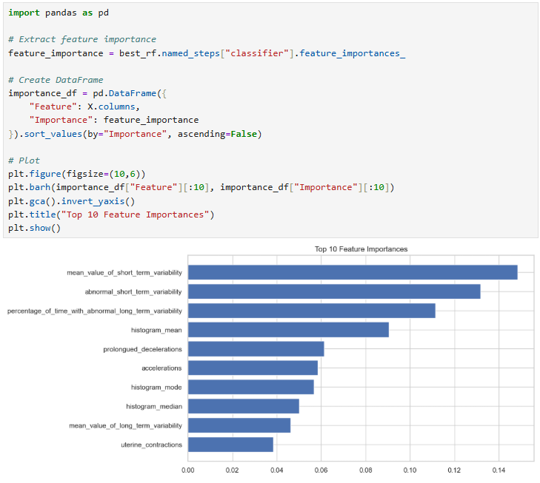
Figure 9: Feature Importance.
Such correspondence of the model output and medical knowledge raises the level of trust in the accuracy of the model. Instead of being a black box, the model draws attention to meaningful patterns that are in line with the existing knowledge in fetal monitoring (Dua and Graff, 2019).
Explainability is also prominent in the medical-related applications where decisions need to be clear and explainable. The model will give an idea on the effects of various measurements on the final overall prediction by determining the most influential features.

System Implementation (Streamlit Application)
The final model was implemented in a web app using Streamlit to show its usability in practice.
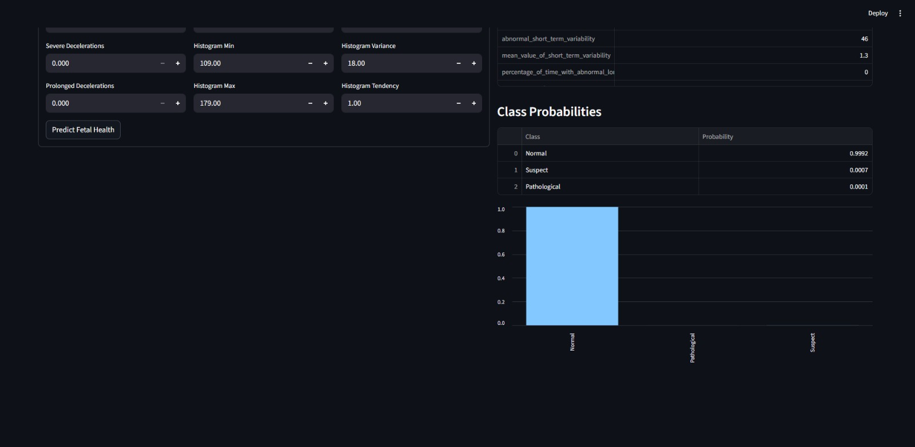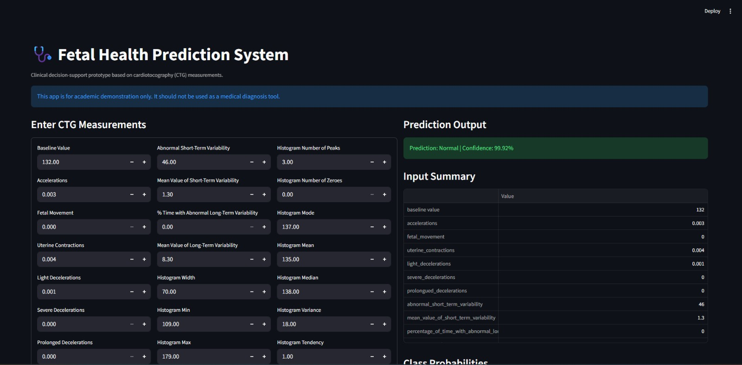
Figure 10: Streamlit Application Interface.
The graphical interface displayed as Figure 10 enables the user to enter the CTG measurements and get the real-time predictions. The system outputs:
- Predicted fetal health category
- Confidence score
- Probability distribution across all classes
The interface will be user friendly, intuitive so that a user does not need technical know how in order to operate the system. The input has well-organised values and outputs are presented in a form that is easy to interpret.
The practice of this aspect enables the model to be an effective decision support instrument rather than a theoretical solution. Although it is not meant as a clinical application, it shows the way machine learning can be used to help interpret medical data.

Limitations
Despite strong performance, several limitations should be acknowledged.
- The dataset is relatively small, which may limit the model’s ability to generalize to larger populations
- Class imbalance affects the prediction of minority classes, particularly the Suspect category
- The model relies solely on CTG features and does not incorporate additional clinical data
- The system has not been validated in a real-world medical environment
Such restrictions point to the fact that the model must be considered as a supportive tool as opposed to a diagnostic system.

Conclusion
This was a machine learning project that generated a classification of fetal health as per the CTG data points.
The tuned Random Forest model was one of the best in that balance between the performance and generalization was realised. It proved to be very accurate and produce similar results among various metrics of evaluation.
The interpretability was improved by adding feature importance analysis, and the usability of the system in the real world was exhibited with the help of the Streamlit example.
All in all, the project shows how machine learning can be applied to aid in fetal health monitoring. The additional and the future research could be focused on expansion of the data, improvement of the model strength and its complementation with the real-life environment.

References
Andrew Mvd (2020) Fetal Health Classification Dataset. Available at: https://www.kaggle.com/datasets/andrewmvd/fetal-health-classification (Accessed: 11 April 2026).
Dua, D. and Graff, C. (2019) UCI Machine Learning Repository: Cardiotocography Data Set. Available at: https://archive.ics.uci.edu (Accessed: 11 April 2026).
Grivell, R.M., Alfirevic, Z., Gyte, G.M.L. and Devane, D. (2015) ‘Antenatal cardiotocography for fetal assessment’, Cochrane Database of Systematic Reviews, Issue 9.
Cömert, Z. and Kocamaz, A.F. (2017) ‘Comparison of machine learning techniques for fetal heart rate classification’, Acta Physica Polonica A, 132(3), pp. 451–454.
Al Duhayyim, M., Alshammari, R., Alharbi, A. and Alotaibi, F. (2023) ‘Ensemble learning for fetal health classification’, Computer Systems Science and Engineering, 47, pp. 1–12.
Regmi, B. and Shah, C. (2023) ‘Classification methods based on machine learning for fetal health analysis’, arXiv preprint. Available at: https://arxiv.org/abs/2311.10962 (Accessed: 11 April 2026).
Nazli, I., et al. (2025) ‘Early detection of fetal health conditions using machine learning’, Diagnostics, 15(10).
Wong, W.K., Juwono, F.H., Apriono, C. and Fitri, I.R. (2025) ‘Fetal health prediction from cardiotocography recordings using Kolmogorov–Arnold networks’, IEEE Open Journal of Engineering in Medicine and Biology, 6, pp. 345–351. Available at: https://doi.org/10.1109/OJEMB.2025.3549594
Zhang, Y., Liu, X., Chen, J. et al. (2023) ‘Fetal health-related study using machine learning approaches’, Frontiers in Endocrinology, 14, Article 1130139. Available at: https://doi.org/10.3389/fendo.2023.1130139

